
Year 10 -General 2019

Mini Test 7 -Semester 2

Statistics

Resources allowed: Calculator and 1 x A4 page one side

Name: ______________________ Class: ______ Time: 50 minutes Total Marks: ____/45

Show working and answers on this sheet. Show working in sufficient detail to support your answers.

Question 1 (1,1,1,1 – 4 Marks)

In a market survey, 200 people were asked how many hours of television they watched in the previous week. Th results are presented in the boxplot below.
- 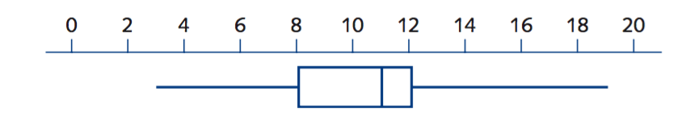
- What is the maximum number of hours anyone watched television?

- What is the median number of hours of television watching?

- What is the interquartile range?

- How many people watched between 8 hours and 11 hours of television?

Question 2 (1 marks)
Select and circle the correct answer

- Box plot

- Box plot and histogram

- Histogram

- neither

The histogram and box plot below show how many hours that people spend watching televisions each week. Which data display can you use to find the largest number of hours?
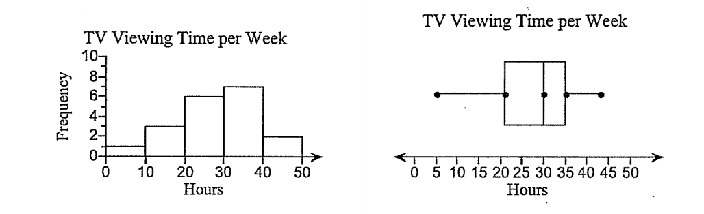

Question 3 (3,2 – 5 Marks)
The boxplot shows the distribution of test scores in a class (Class A) of 20 students.

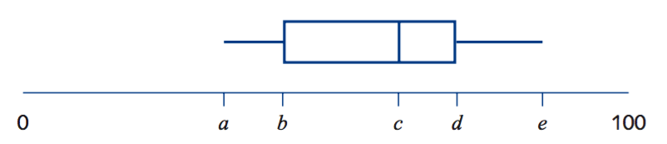
The lowest score in the class was 38, the range of the scores was 50 and the median was 61.

- Write down the values of a = c = e =

- When all the test scores were added up the total was 1240. What was the mean of the test scores?

Question 4 (5, 5 -10 Marks)
The number of late passes issued daily by a school over a four week period were as follows:

4, 4, 4, 5, 5, 6, 6, 6, 6, 7, 7, 7, 7, 8, 8, 8, 9, 9, 10, 14

- Determine the five number summary for this data.

- Use the five number summary to construct a box plot on the scale below that reflects your response in (b).

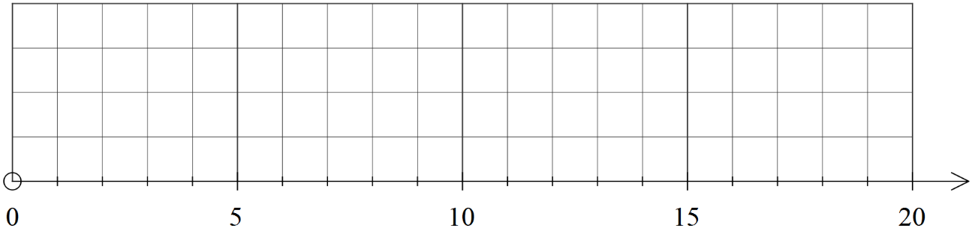

Question 5 (4 marks)

Given that the four sets of data that were used to create the histograms shown below were also used to create the four boxplots, match each histogram with its corresponding boxplot
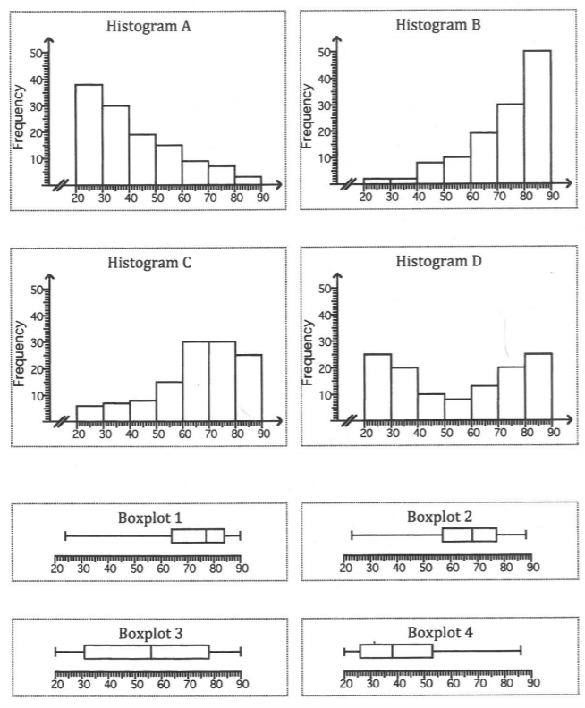

Histogram___ matches boxplot ___

Histogram___ matches boxplot ___

Histogram___ matches boxplot ___

Histogram___ matches boxplot ___

Question 6
(1,1,2,2,2 – 8 Marks)
Two PE classes of students have their pulse rates (in beats per minute) measured. The results are shown in these box plots.
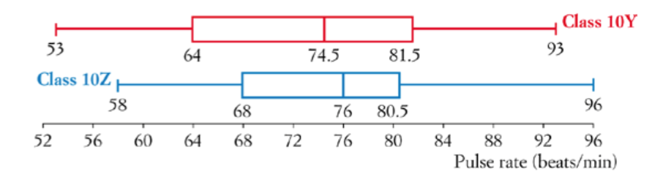
- What was the lowest pulse rate across both classes?

- Find the interquartile range for class 10Z.

- If there are 24 students in class 10Y, how many had a pulse rate between 74.5 and 81.5?

- Which class had the higher pulse rate on average? How does the box plot show this?

- Which class had more spread of pulse rates? How does the box plot show this?

Question 7 (5, 5, 3 -13 Marks)

The data below gives the average monthly minimum daily temperatures of two Australian cities. The months are in order: January to December.

Perth: 11.2, 11.8, 13.2, 9.3, 7.4, 5.8, 4.3, 5.9, 6.9, 19.8, 18.3, 12.4

Sydney : 23.2, 22.6, 18.4, 14.5, 7.2, 4.1, 3, 6.9, 8.7, 13.1, 18.3, 22.4

- Draw a parallel box plot for the two cities.



- Compare and contrast the temperature of these the two cities.

~End of Test~

